Osceola Middle School

Chiefs Weekly Updates
Week of September 19, 2022

General Announcements:
- When needing to pick your child up from school early for an appointment please call ahead to the grade level offices to let the clerk know when you will be at school. This will speed up the process especially if your child is on the PE field and needs to come in to change clothes before leaving or during lunches.
  - 6th Grade office extension 2129
  - 7th Grade office extension 2133
  - 8th Grade office extension 2126
  - Please present a Photo ID to check out your child.
  - No Permits to Leave will be administerd after 3:45 p.m.
  - Parent/Teacher Conferences are scheduled each Tuesday morning at 8:50 a.m. Please contact your child’s grade level office to schedule conferences.

STUDENT DROP OFF:
The visitor parking lot is to be used for our Special Needs families to drop off and pick up their students only. Some of these children lack safety awareness and the parents must walk the student to meet the teachers by the front doors.

Parent drop off and pick up is either in our car line by the gym or across the street at Osceola High School loop.

If you have any questions regarding this issue please see Dr. Lowery.

Online Tips and Information
Canvas Resources
- My PCS Online Parent Info (Parent Tour-3:33)
https://www.youtube.com/watch?time_continue=1&v=Jwxf_R3sHzA&feature=emb_logo
- Getting started-Scholars (4:35) https://www.youtube.com/watch?v=iJnfNk0uk_I&feature=youtu.be
- Canvas 101 for Parents
  - Parent/Family Training Course(about 10 minutes)

https://pcsb.instructure.com/courses/77992
- Canvas LMS for Parents (4:40) https://pcsb.instructure.com/courses/77992/pages/types-of-parent-access

- Register to stay informed on the status of your child’s bus…
Pinellas County Schools Transportation Department is implementing a new system to inform you when your child’s bus is going to be delayed. Our school is part of a pilot effort to use a system called Bus Bulletin.
The Bus Bulletin notification system will notify schools, parents and students when there are bus delays and schedule changes. If you would like to receive instant notifications when delays or incidents affect your student's bus, please register with Bus Bulletin.
- There’s no cost to you for this service.

- Registration is simple and fast.
- You can choose to receive either text messages, phone calls, and e-mails or all of these options.
- All contact information is stored securely and will not be shared or sold. Your privacy is protected.
- Please note: this system is not related to Pinellas County Schools new emergency text message communications through SchoolMessenger.
For more information, or to sign-up and start receiving notifications, please visit: www.BusBulletin.com/parents.
If you need assistance with registration, call Pinellas County Schools Transportation Department at 727-587-2020.

- PTSA: Join PTSA for $10
Join us on Facebook at: https://www.facebook.com/omsptsa1/

Meeting Dates for the school year:
September 28th 5:30 SAC – 6pm PTSA – Topic: Bullying

November 30th 5:30 SAC – 6pm PTSA – Topic: High School Options

January 25th 5:30 SAC – 6pm PTSA – Topic: Mental Health/Suicide

February 22nd 5:30 SAC – 6pm PTSA – Topic: You Tube Controls

March 29th 5:30 SAC – 6pm PTSA – Topic: FDLE

April 26th 5:30 SAC – 6pm PTSA – Topic: NOPE

- OMS Food Pantry
OMS runs a Food Pantry for our families in need throughout the entire year. If you or someone you know is in need of food please have them come into the school at any time! We are still asking students to donate non-perishable food items. Stop by the school or contact Michelle Shepard at shepardm@pcsb.org if you have any questions.
- Non-perishable food items are needed to fill the food pantry. Please bring the items to the front office. Again we will be counting the items towards the Spirit Stick Points so please make sure to put what grade level the donation is from! Thank you in advance for supporting our pantry!

- From the Cafeteria: Go to www.myschoolapps.com to apply for free and reduced lunches. Only families receiving letters that they do not need to reapply are grandfathered in. You can put money on your child’s account at www.myschoolbucks.com. You can also send cash or a check into school to be put on your child’s lunch account. ALL BREAKFAST AND LUNCHES ARE FREE FOR THE 2022-2023 SCHOOL YEAR. We are a CEP School, which means that we have enough families qualify for Free or Reduced lunches that everyone now qualifies. Please help us keep lunches free by still filling out the application for this school year.
- The YMCA program is held onsite for before and after school care. If you are interested in this program for your child please go to www.ymcasuncoast.org to register.

- VOLUNTEERS NEEDED!! We need volunteers for the front office and testing proctors. Please contact Mrs. Hendricks at hendricksko@pcsb.org to schedule time to help out. If you do plan to go on a field trip with your child this year, please get registered or updated now to save time later. To reactivate your volunteer status please go to Focus and log in with your Volunteer log in and password. The user name will start with a v.last name first initial (no spaces). The password will be your last name, first letter of your first name capatilized and the year of your birth. If you have any issues please contact Mrs. Hendricks.
  - If you are interested please contact the school office so we can get you set up. It takes 3 weeks to approve a volunteer so please register early!

    - https://asd.pcsb.org/schoolwiresforms/volunteer/ to register to go on field trips. You will need to upload a photo ID.

Additional Important Dates: START WITH HELLO WEEK
- Monday, September 19, 2022 HEY DAY – Say Hello
  - Volleyball Game Home – Boys First 4:45pm
  - Audio Visual Club Meeting – Media Center 4:15-5:15

- Tuesday, September 20, 2022 WEAR GREEN
  - GSA Meeting – 8am Art Room
  - Mural Club Meeting – 4:15-5:30
  - Volleyball Practice 4:15-5:30

- Wednesday, September 21, 2022 WHAT’S UP DAY
  - Volleyball Game Home – Girls First 4:45pm

- Thursday, September 22, 2022 KINDNESS DAY
  - Audio Visual Club Meeting – Media Center 4:15-5:15
  - Spirit Day – Oh Gelato!
  - Volleyball Practice 4:15-5:30

- Friday, September 23, 2022 WHERE ARE YOU FROM?
  - Unclub Meeting – 5-202 8:30am Meet at Bus Circle Entrance
  - Heritage Day – Wear a shirt that shows us where you’re from!

September Fun Friday Tees
9/30 – College Shirt Day

AVID NEEDS:
We are still looking for 2-3 more AVID tutors. I am attaching a contract that you can share this gives more detail on what they need. The minimum requirements are:
- College Student Enrolled in at least 9 Credit Hours
- Have a Cumulative 2.75 GPA or Higher

Here is the website page that can give you info too. https://www.pcsb.org/Page/11524

They would be working with either Mrs. Juergens or Ms. Blanco and they can use them even if tutors can only come half day.

Any questions please contact Ms. Blanco at blancoali@pcsb.org


Anyone still interested in joining the Fishing Club please see Mr. Schiller in Room 4-207 or email at schillerjo@pcsb.org.
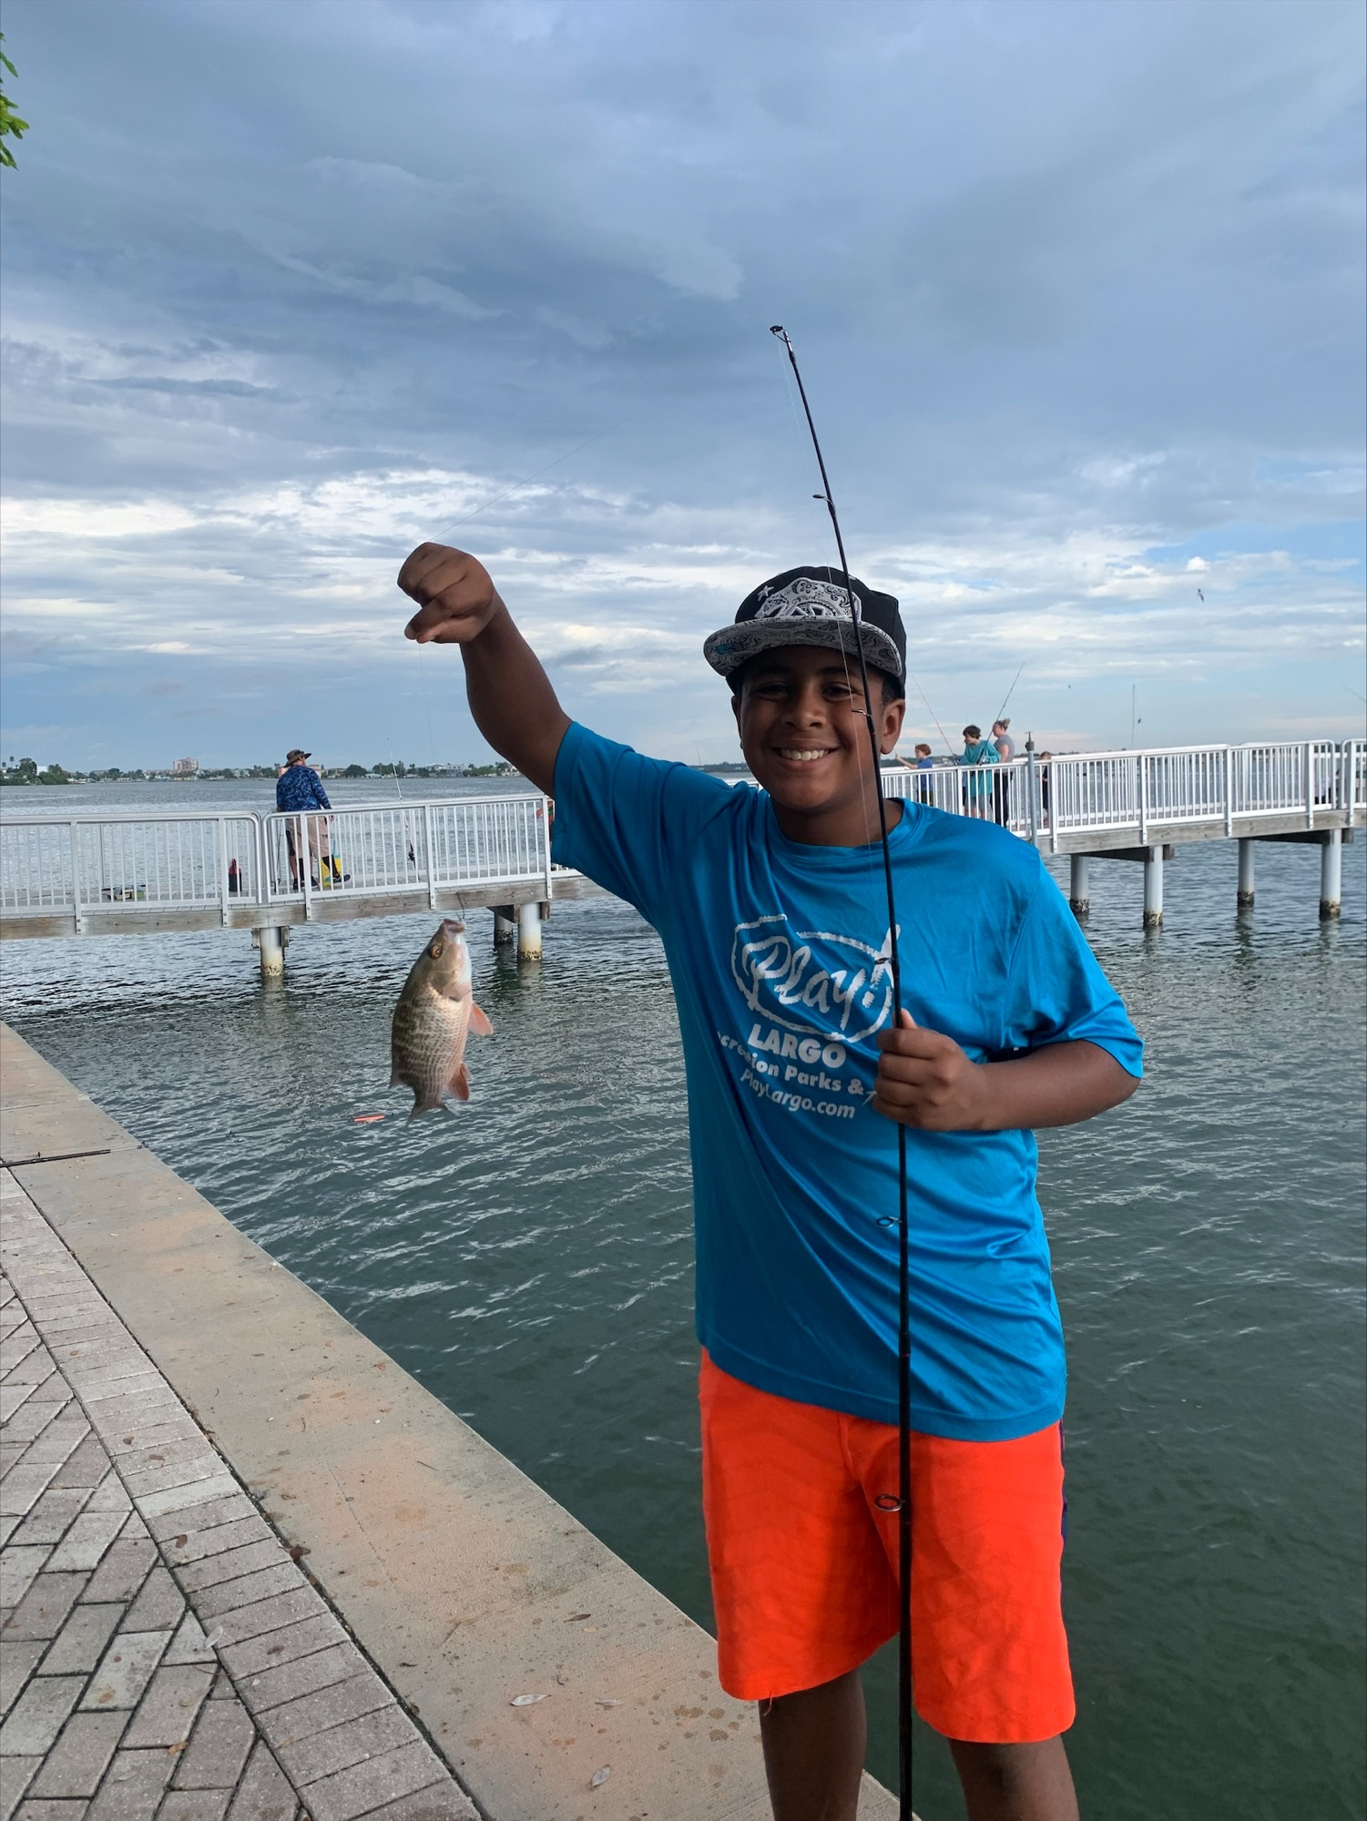

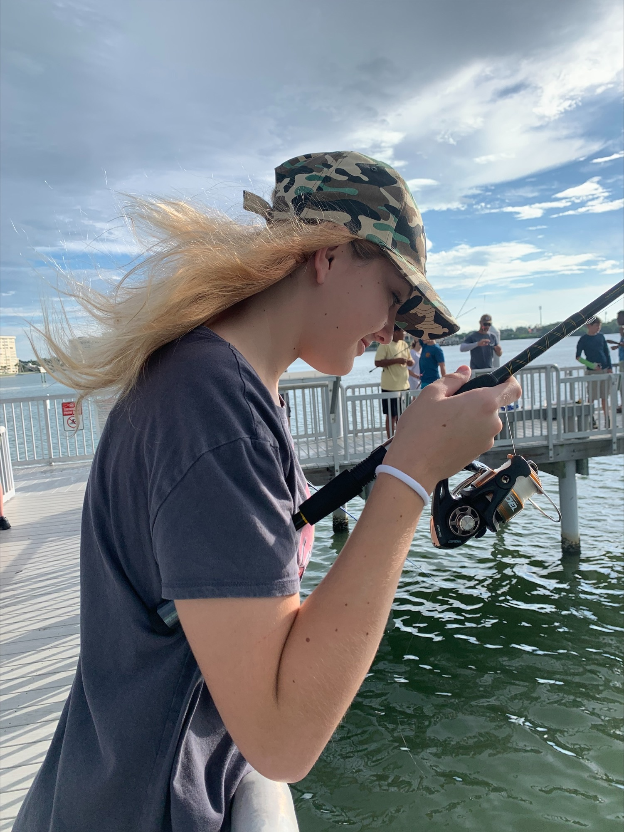

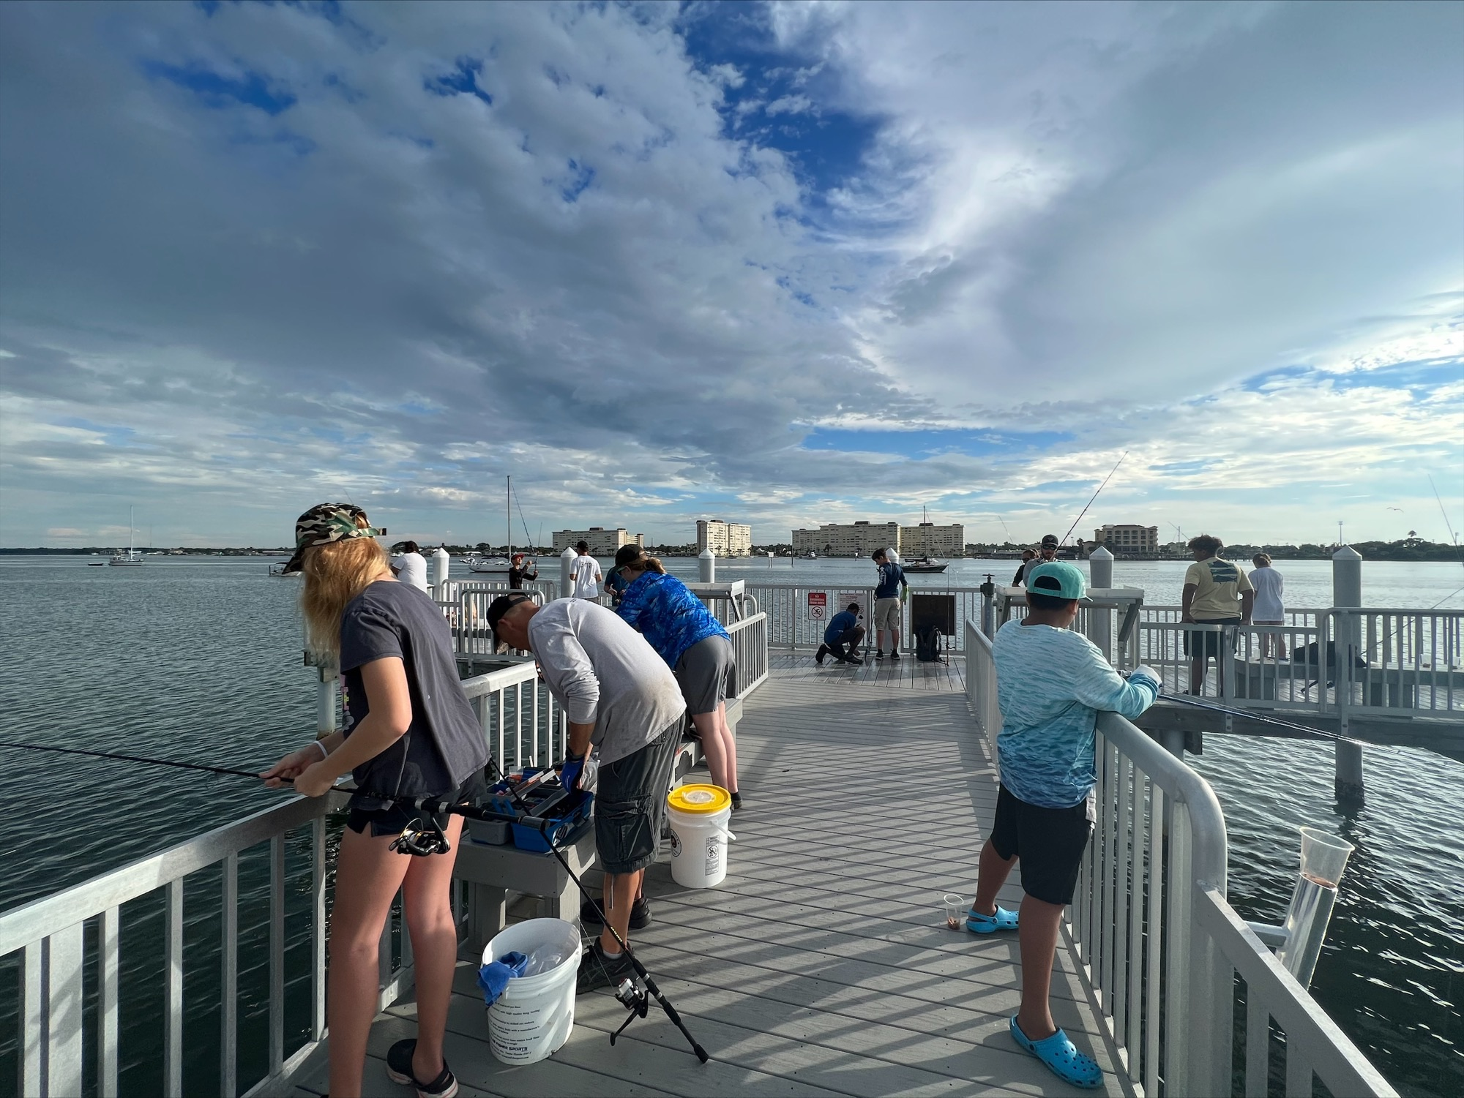
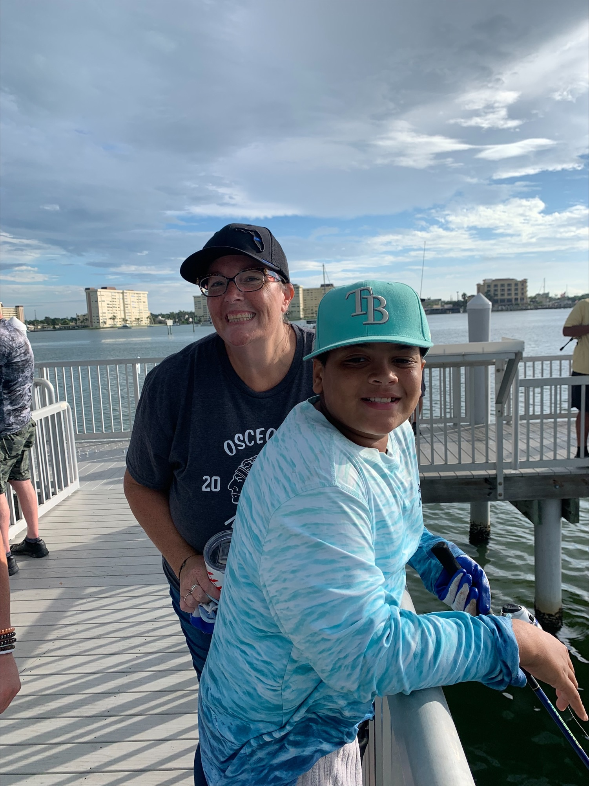

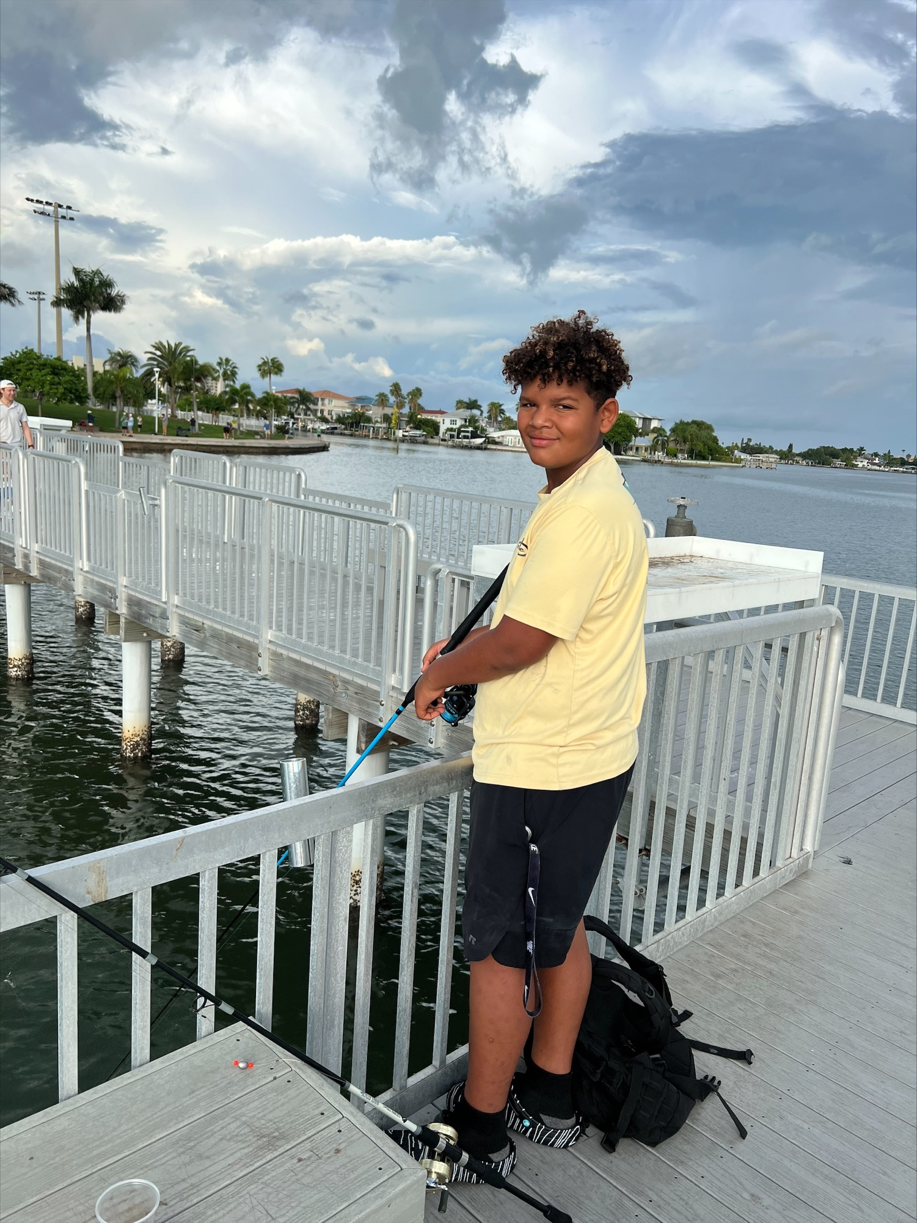

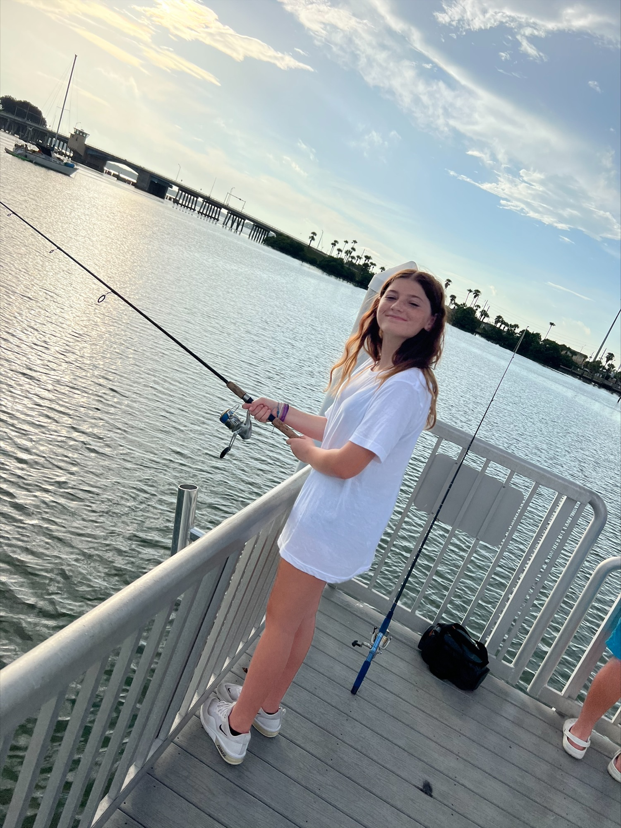

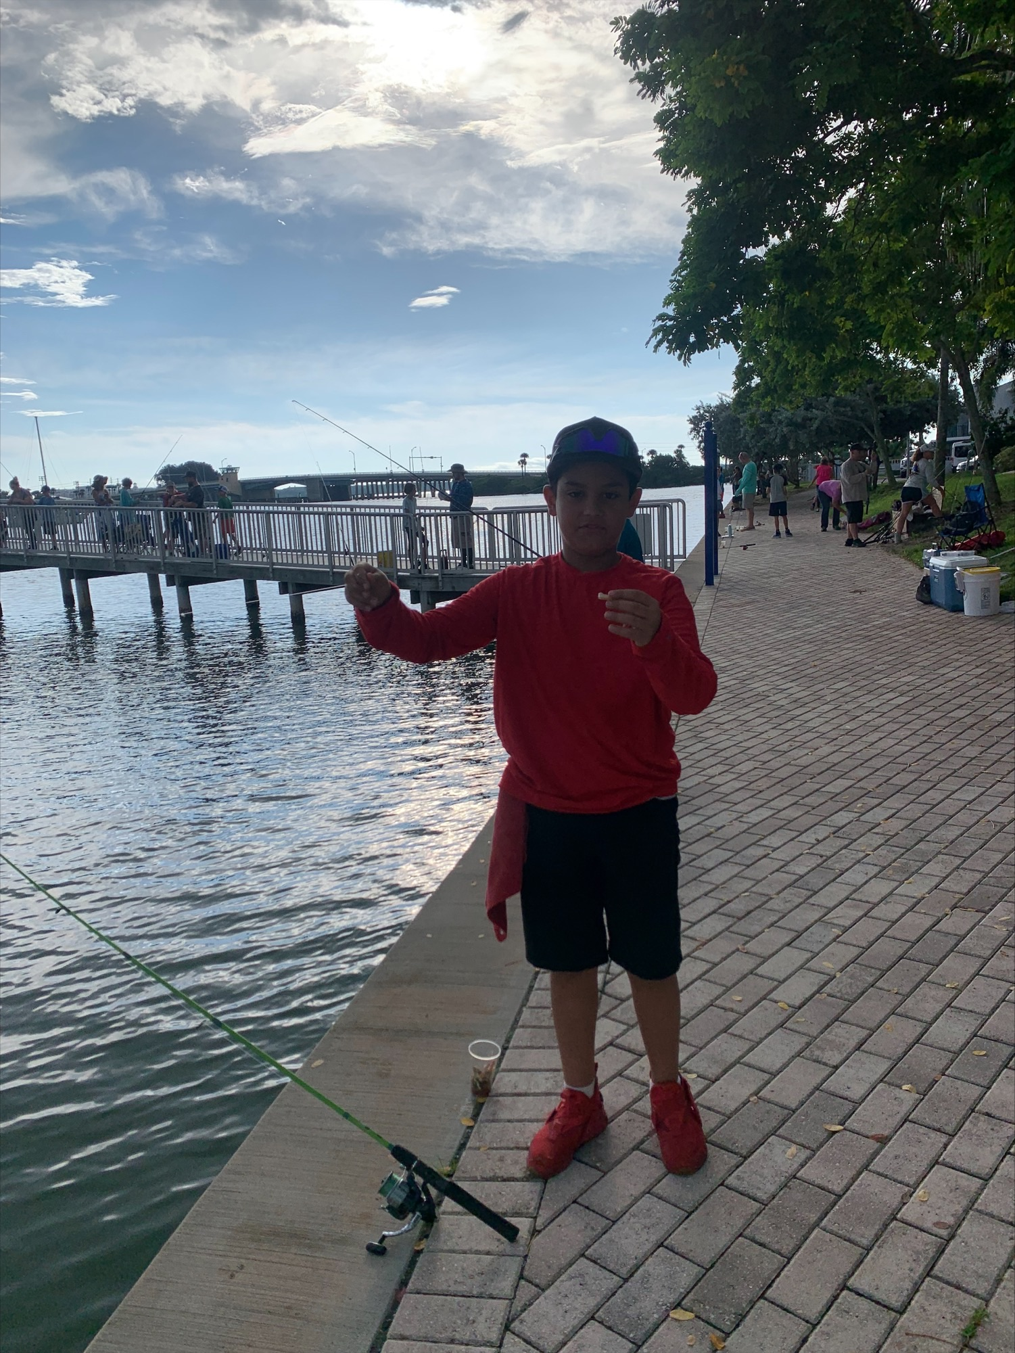
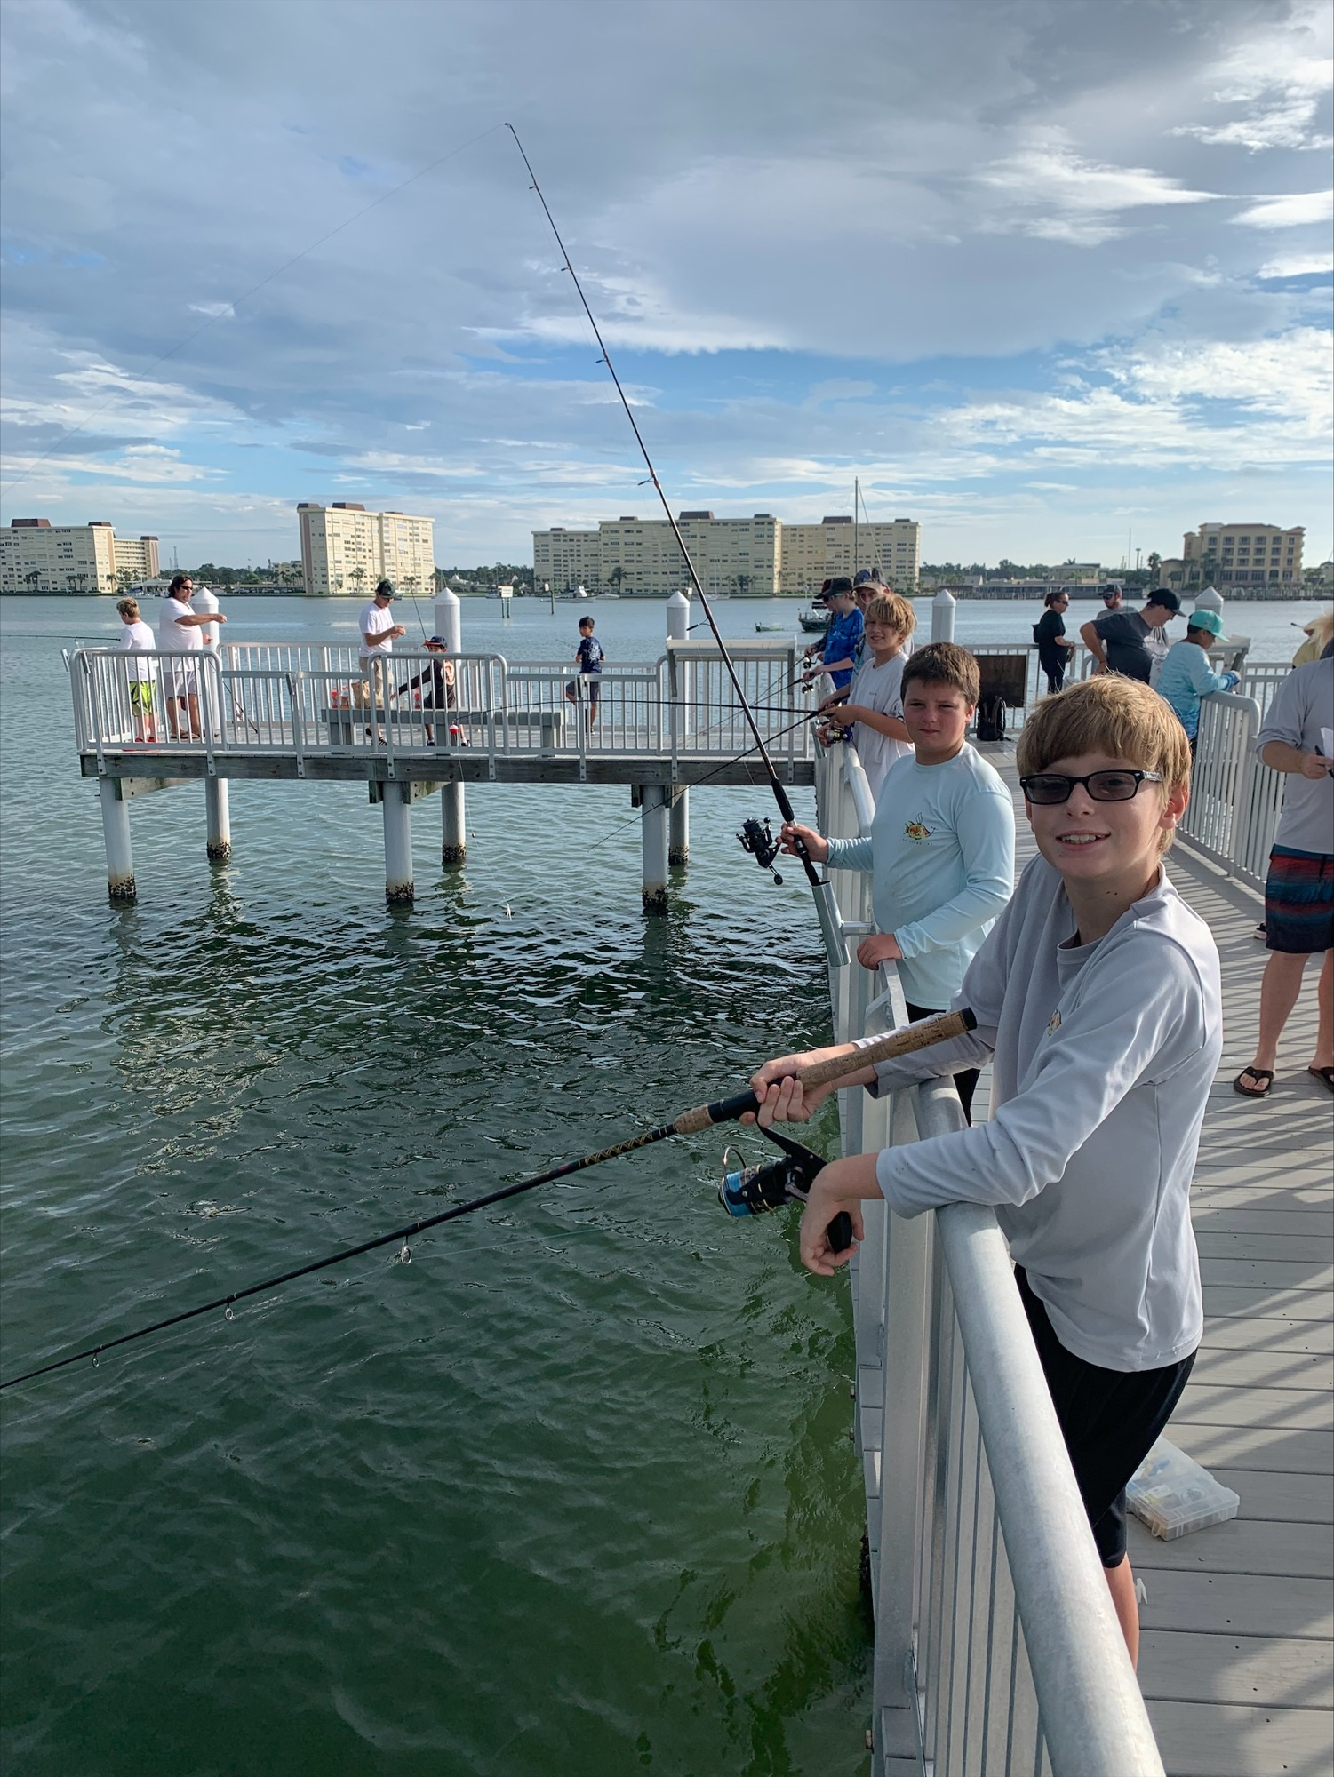

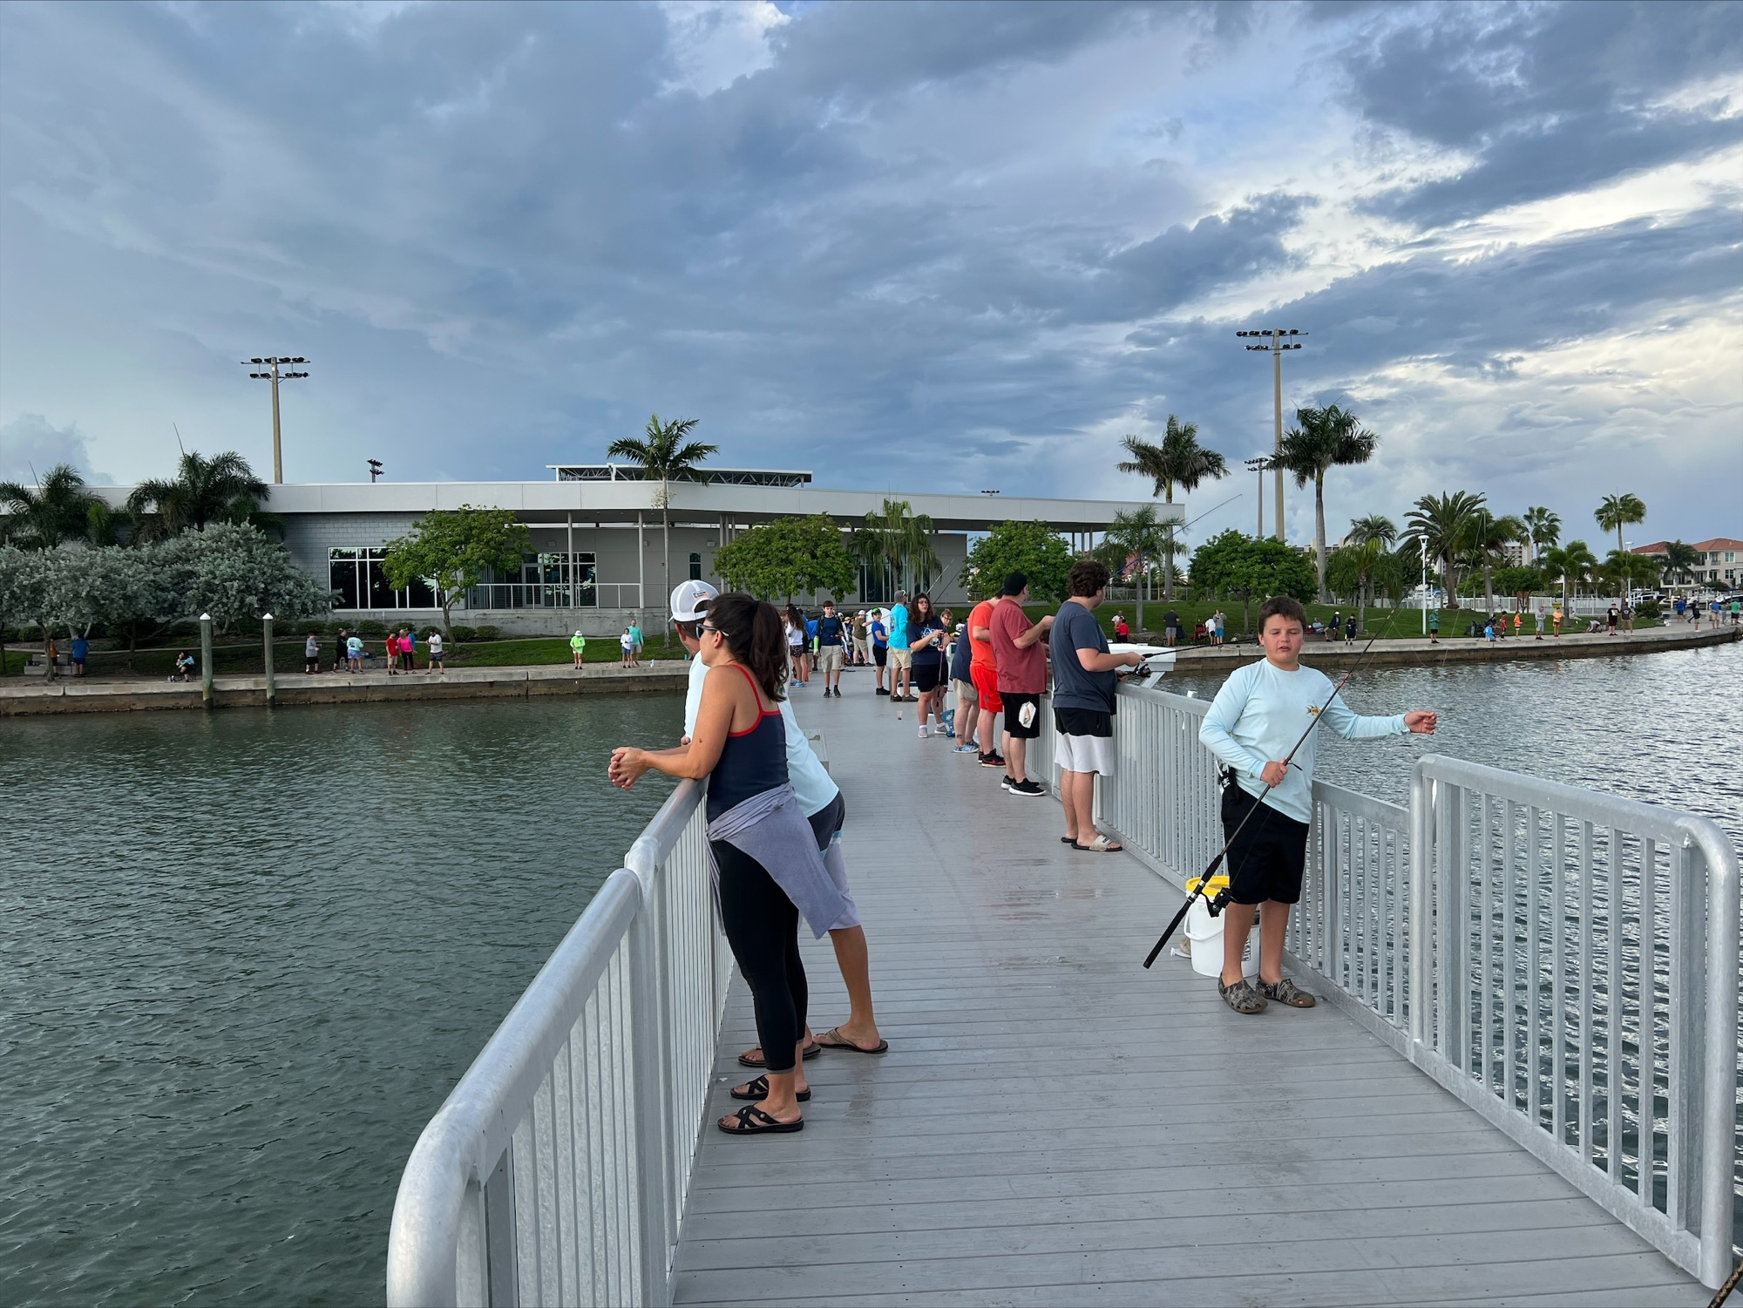

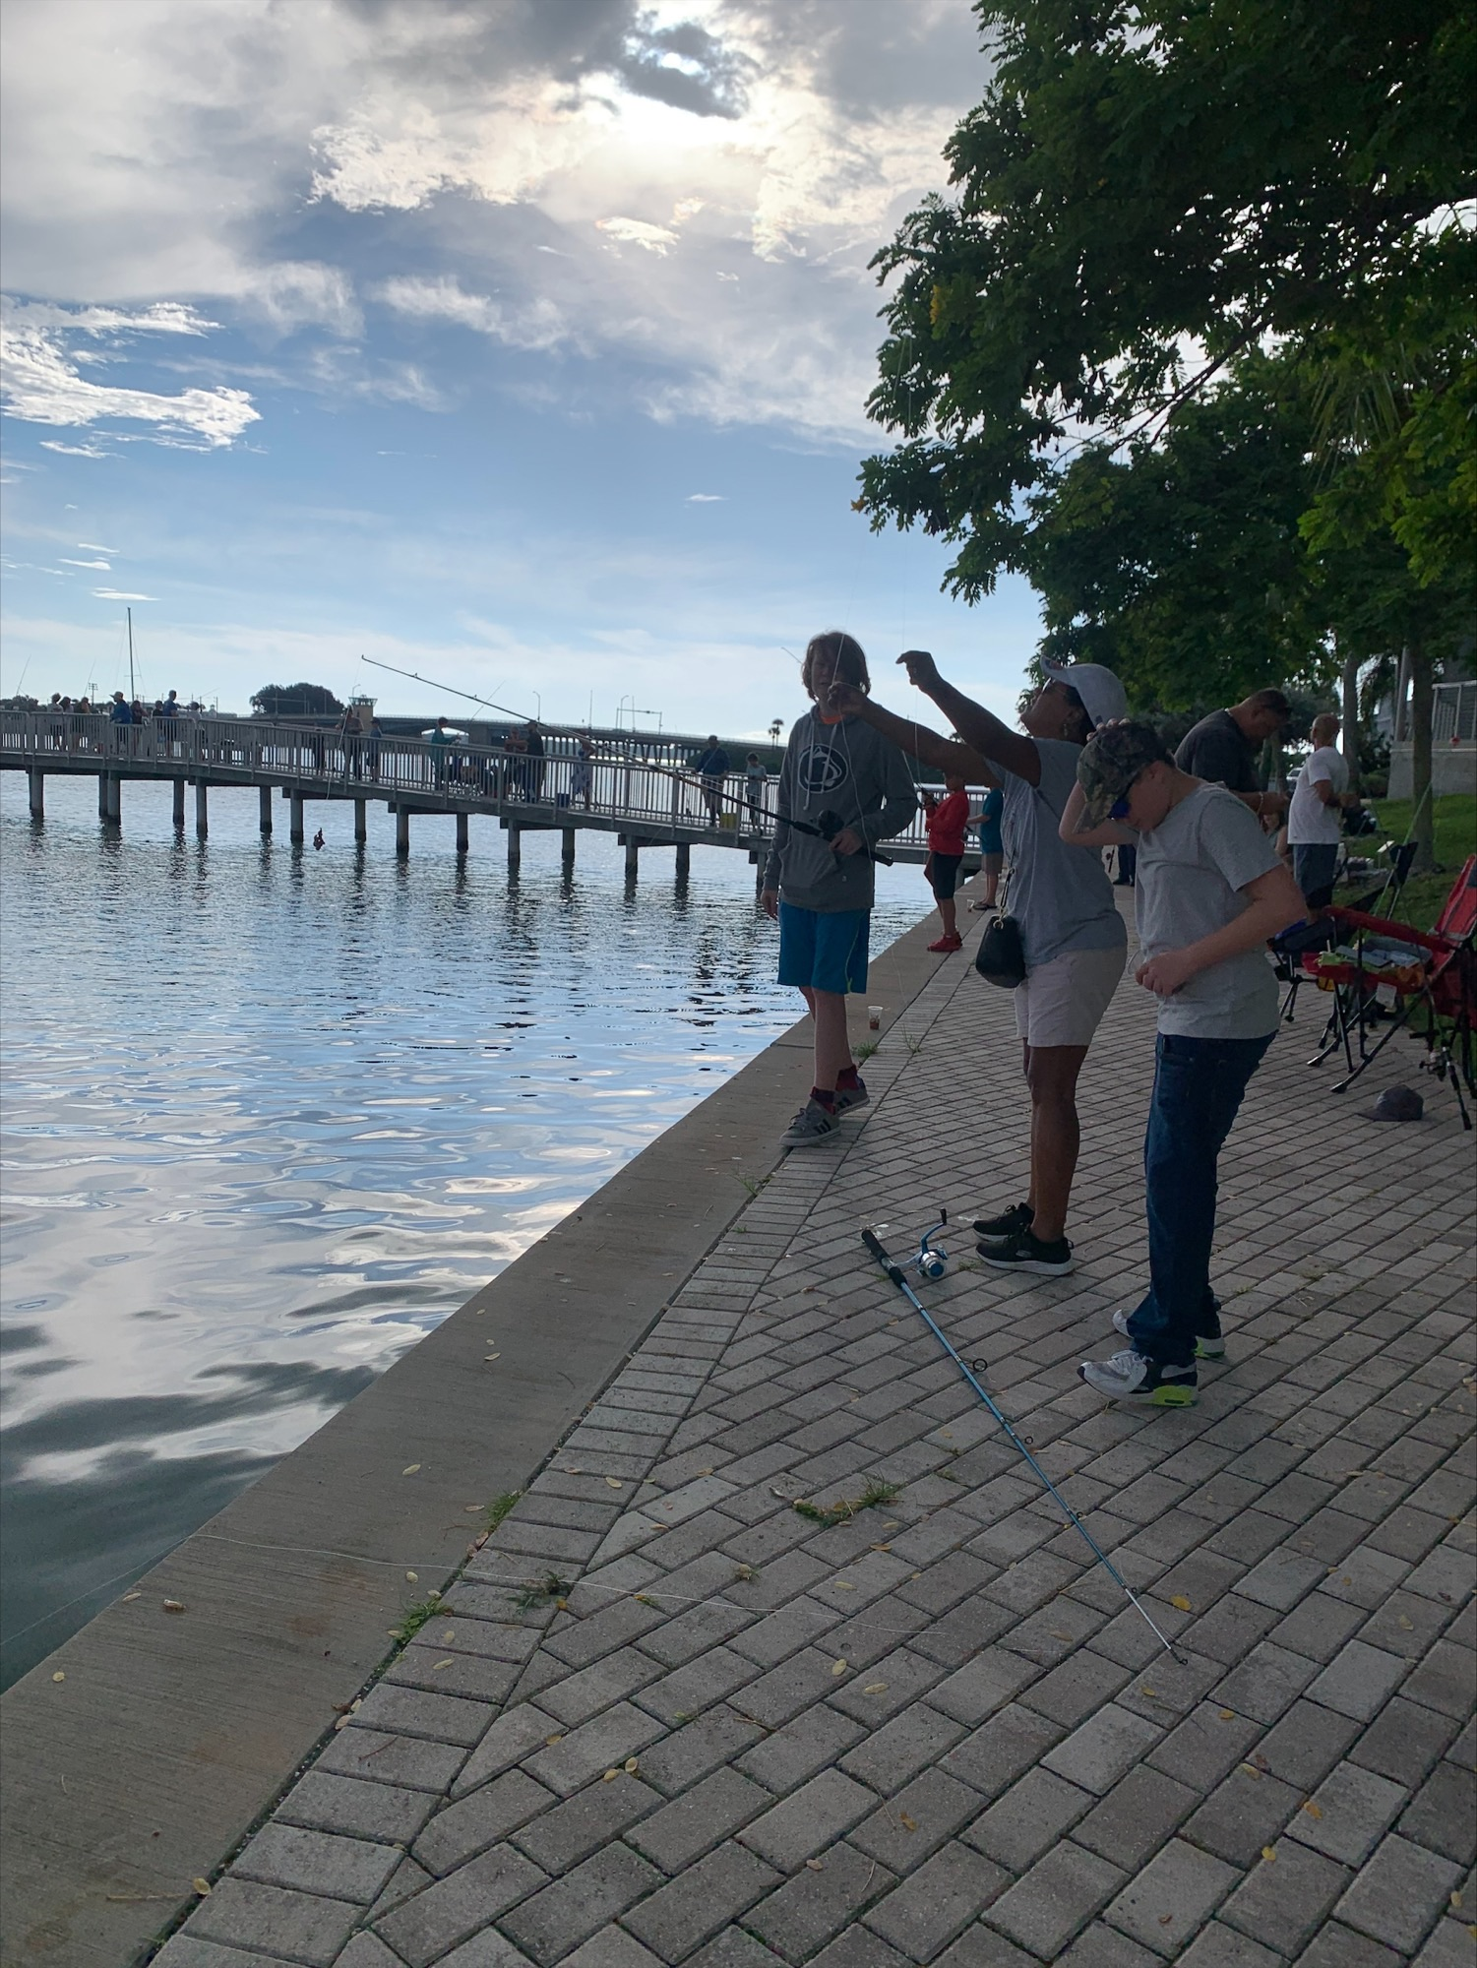
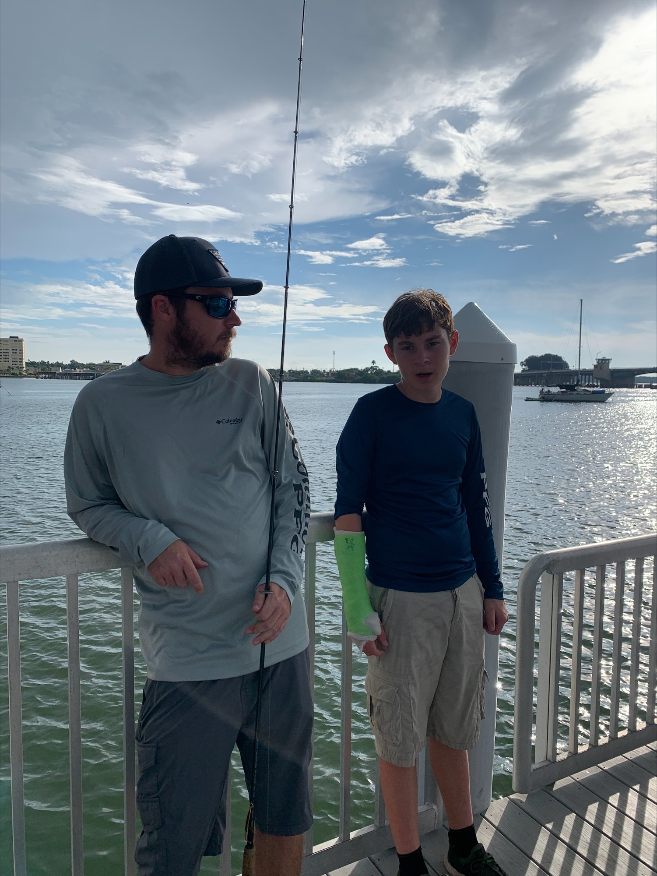

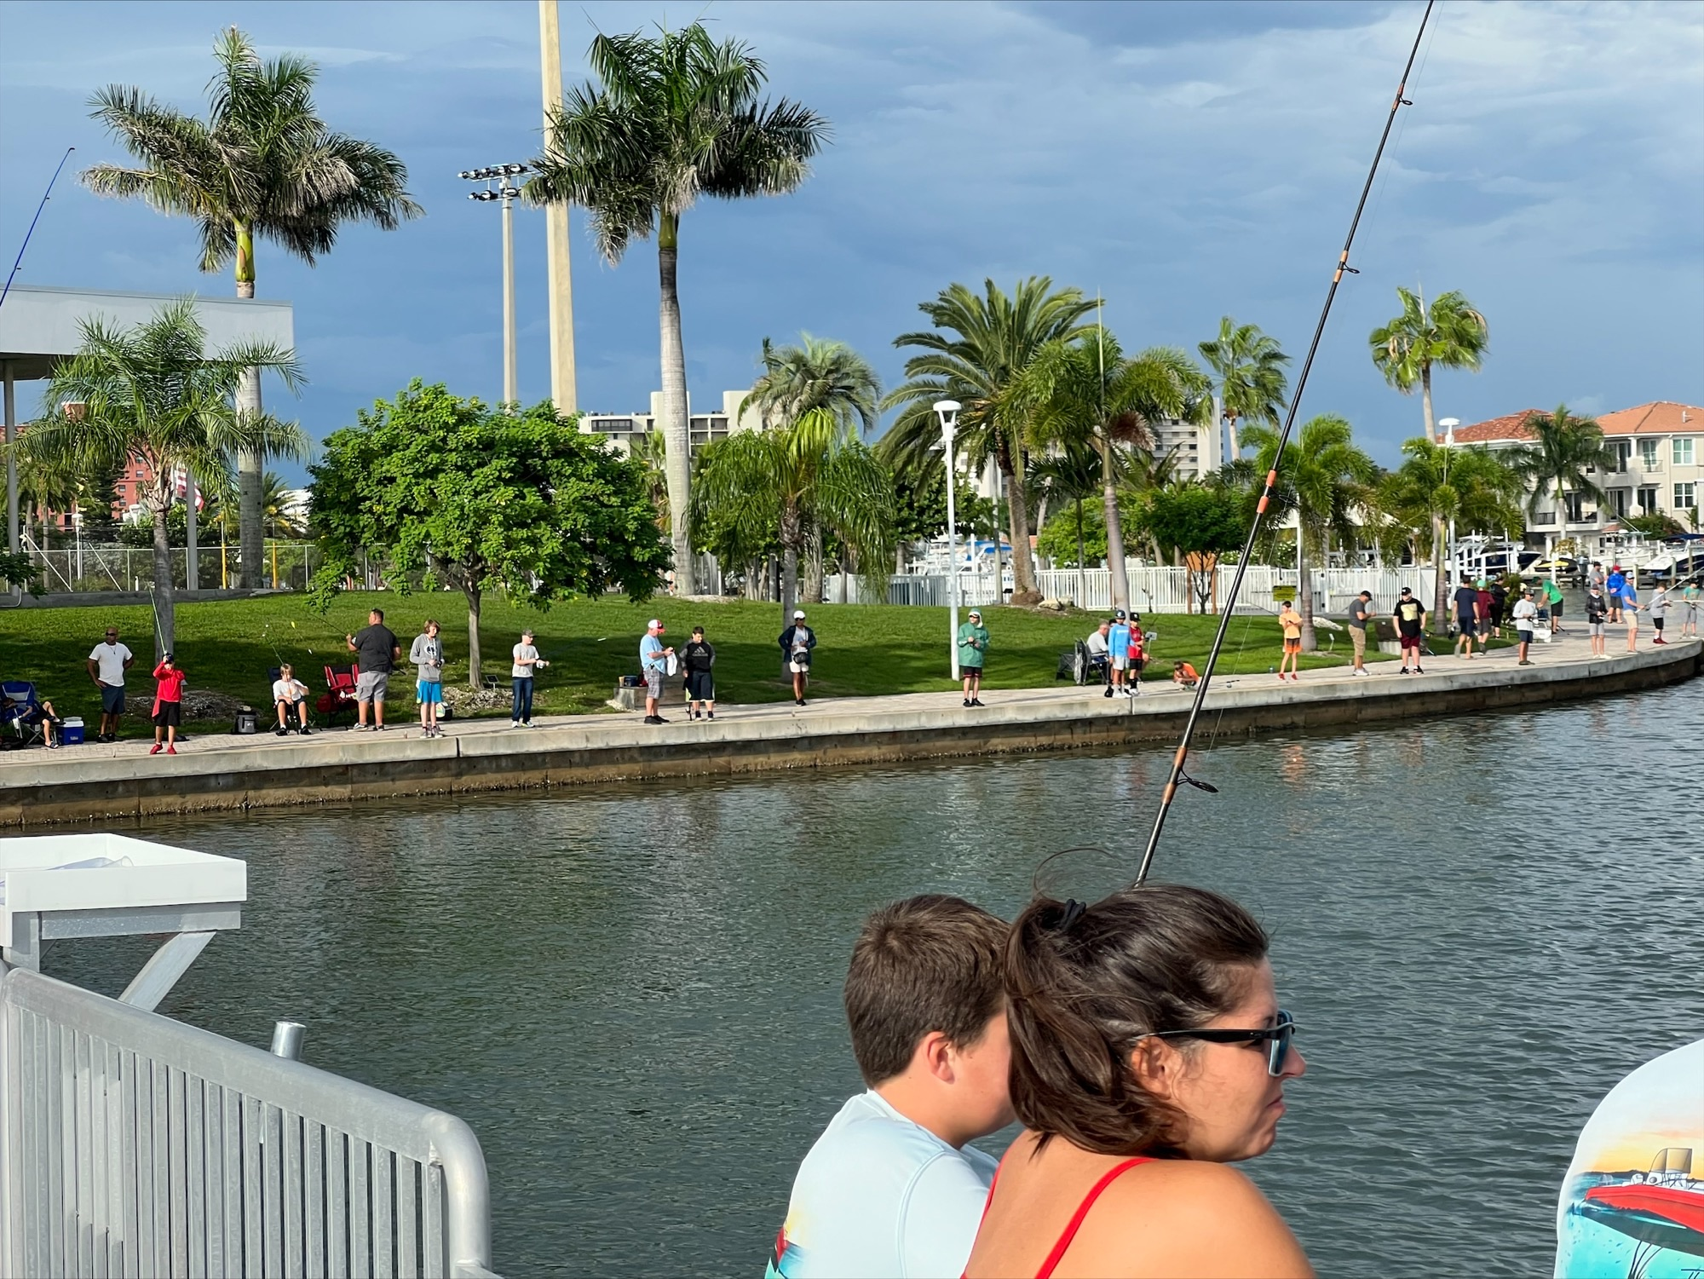

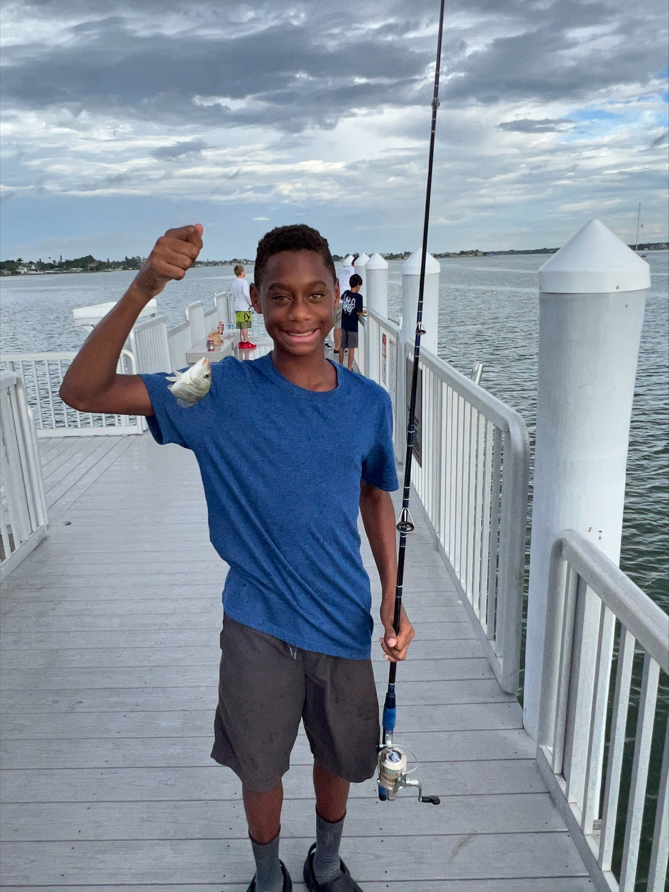
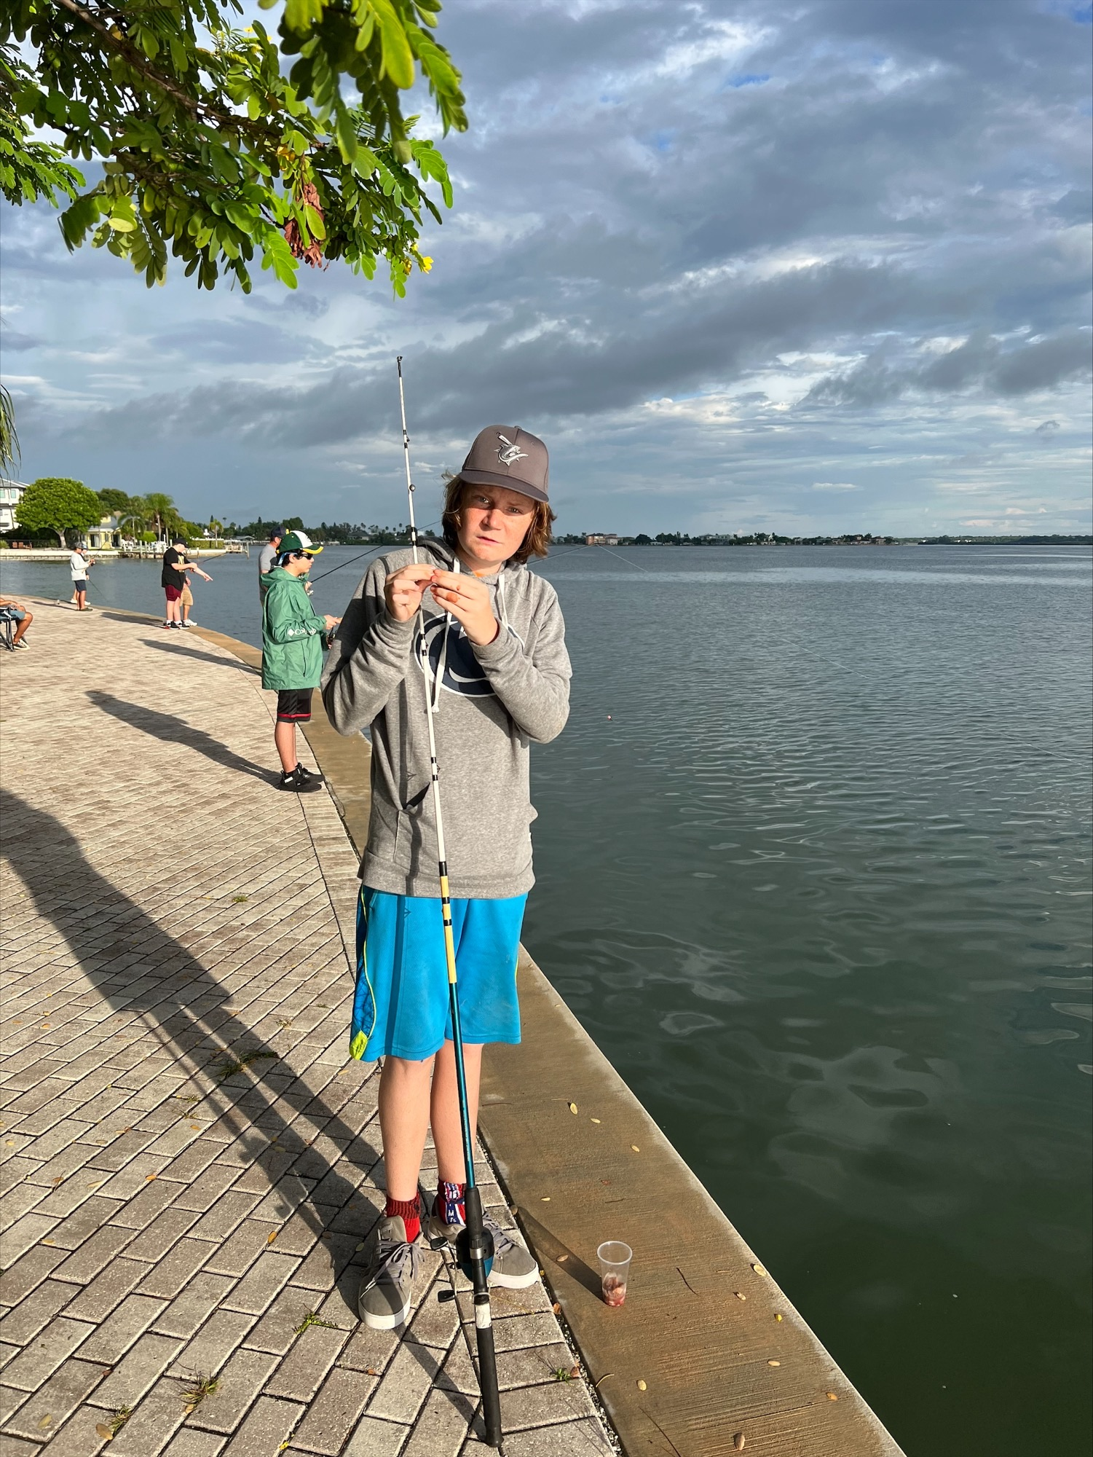

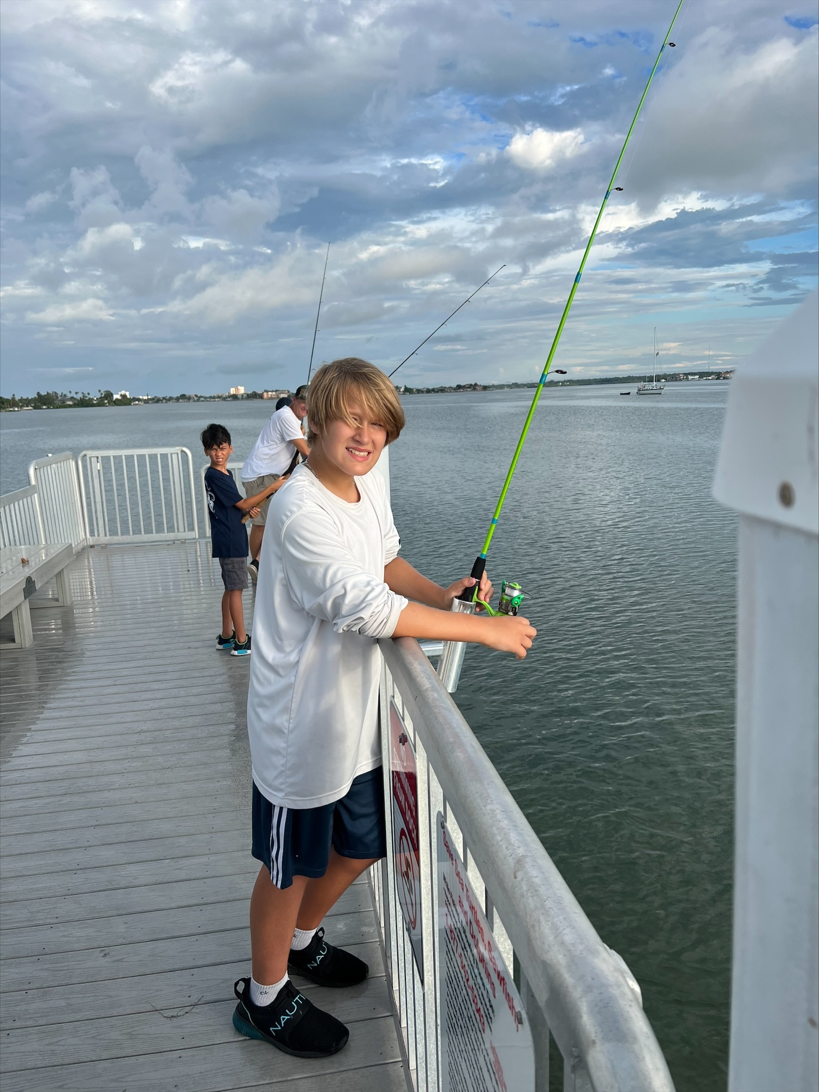

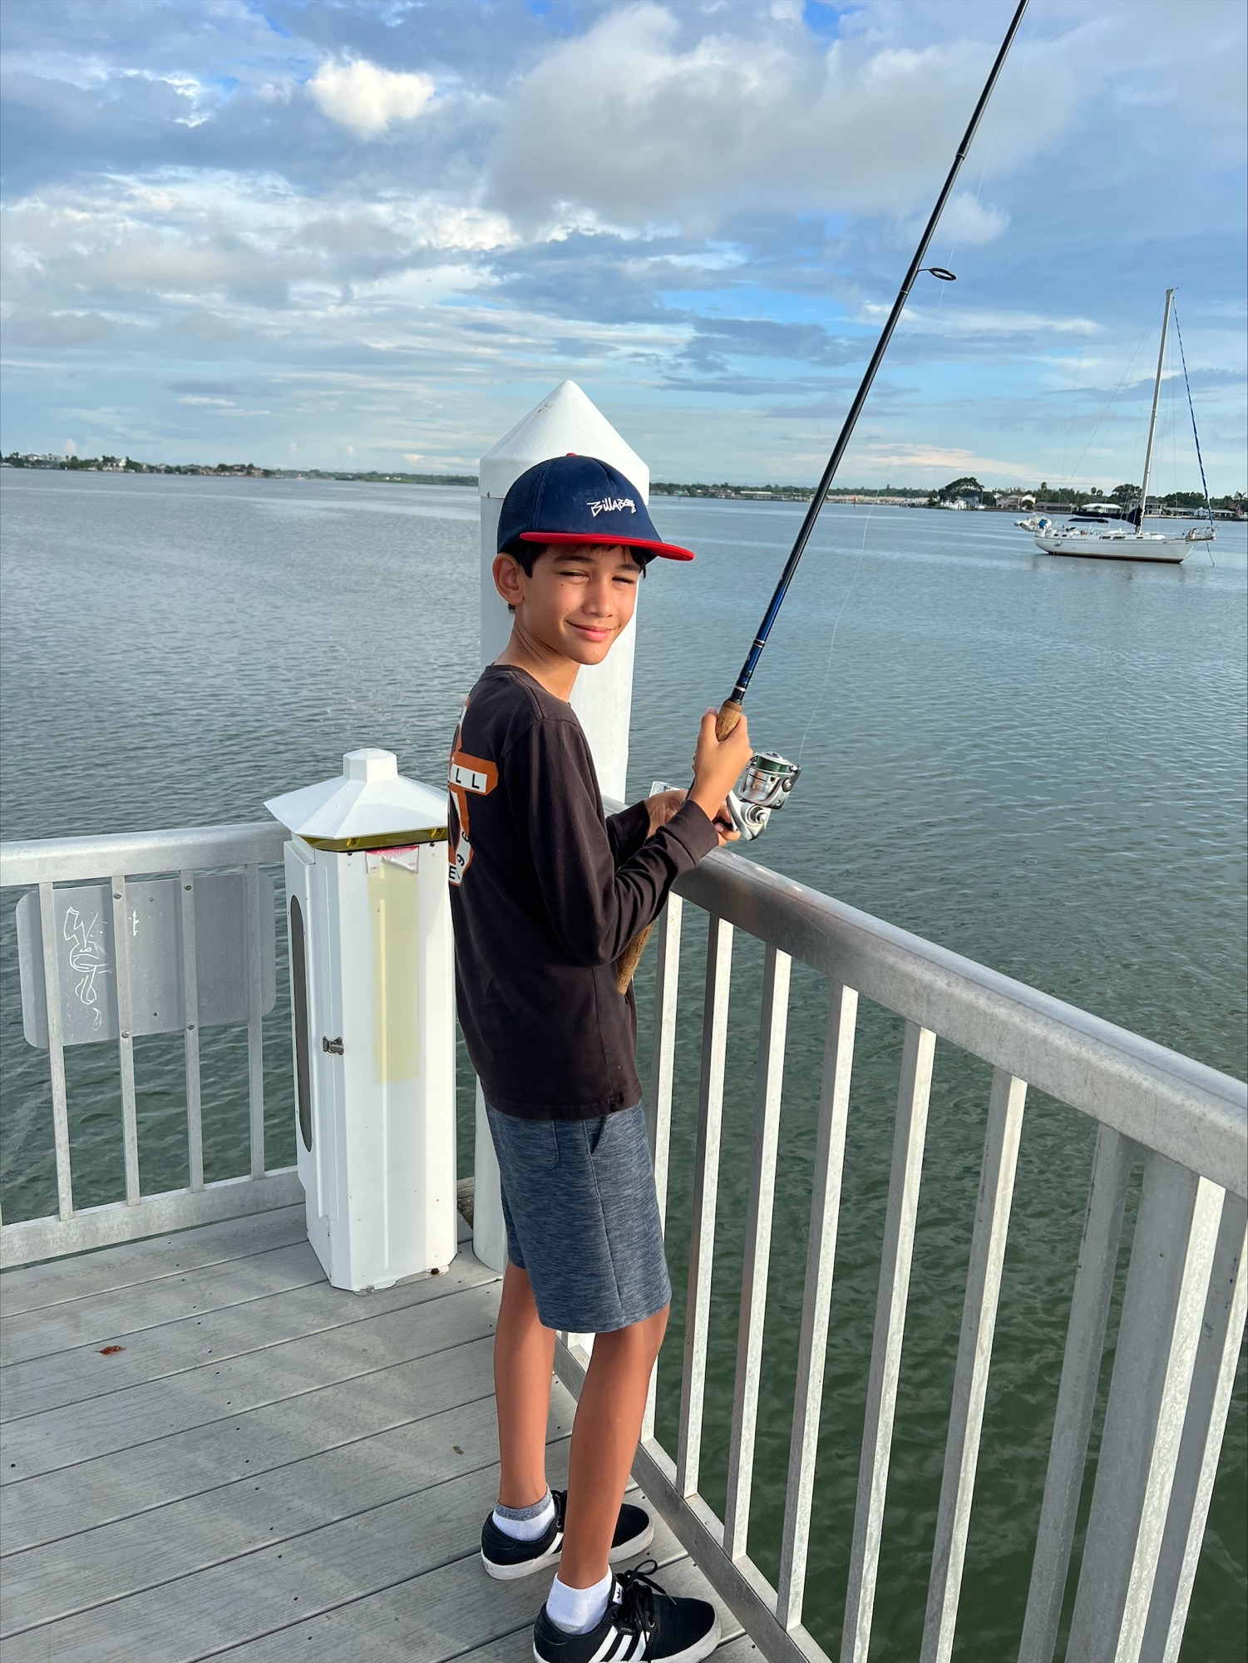
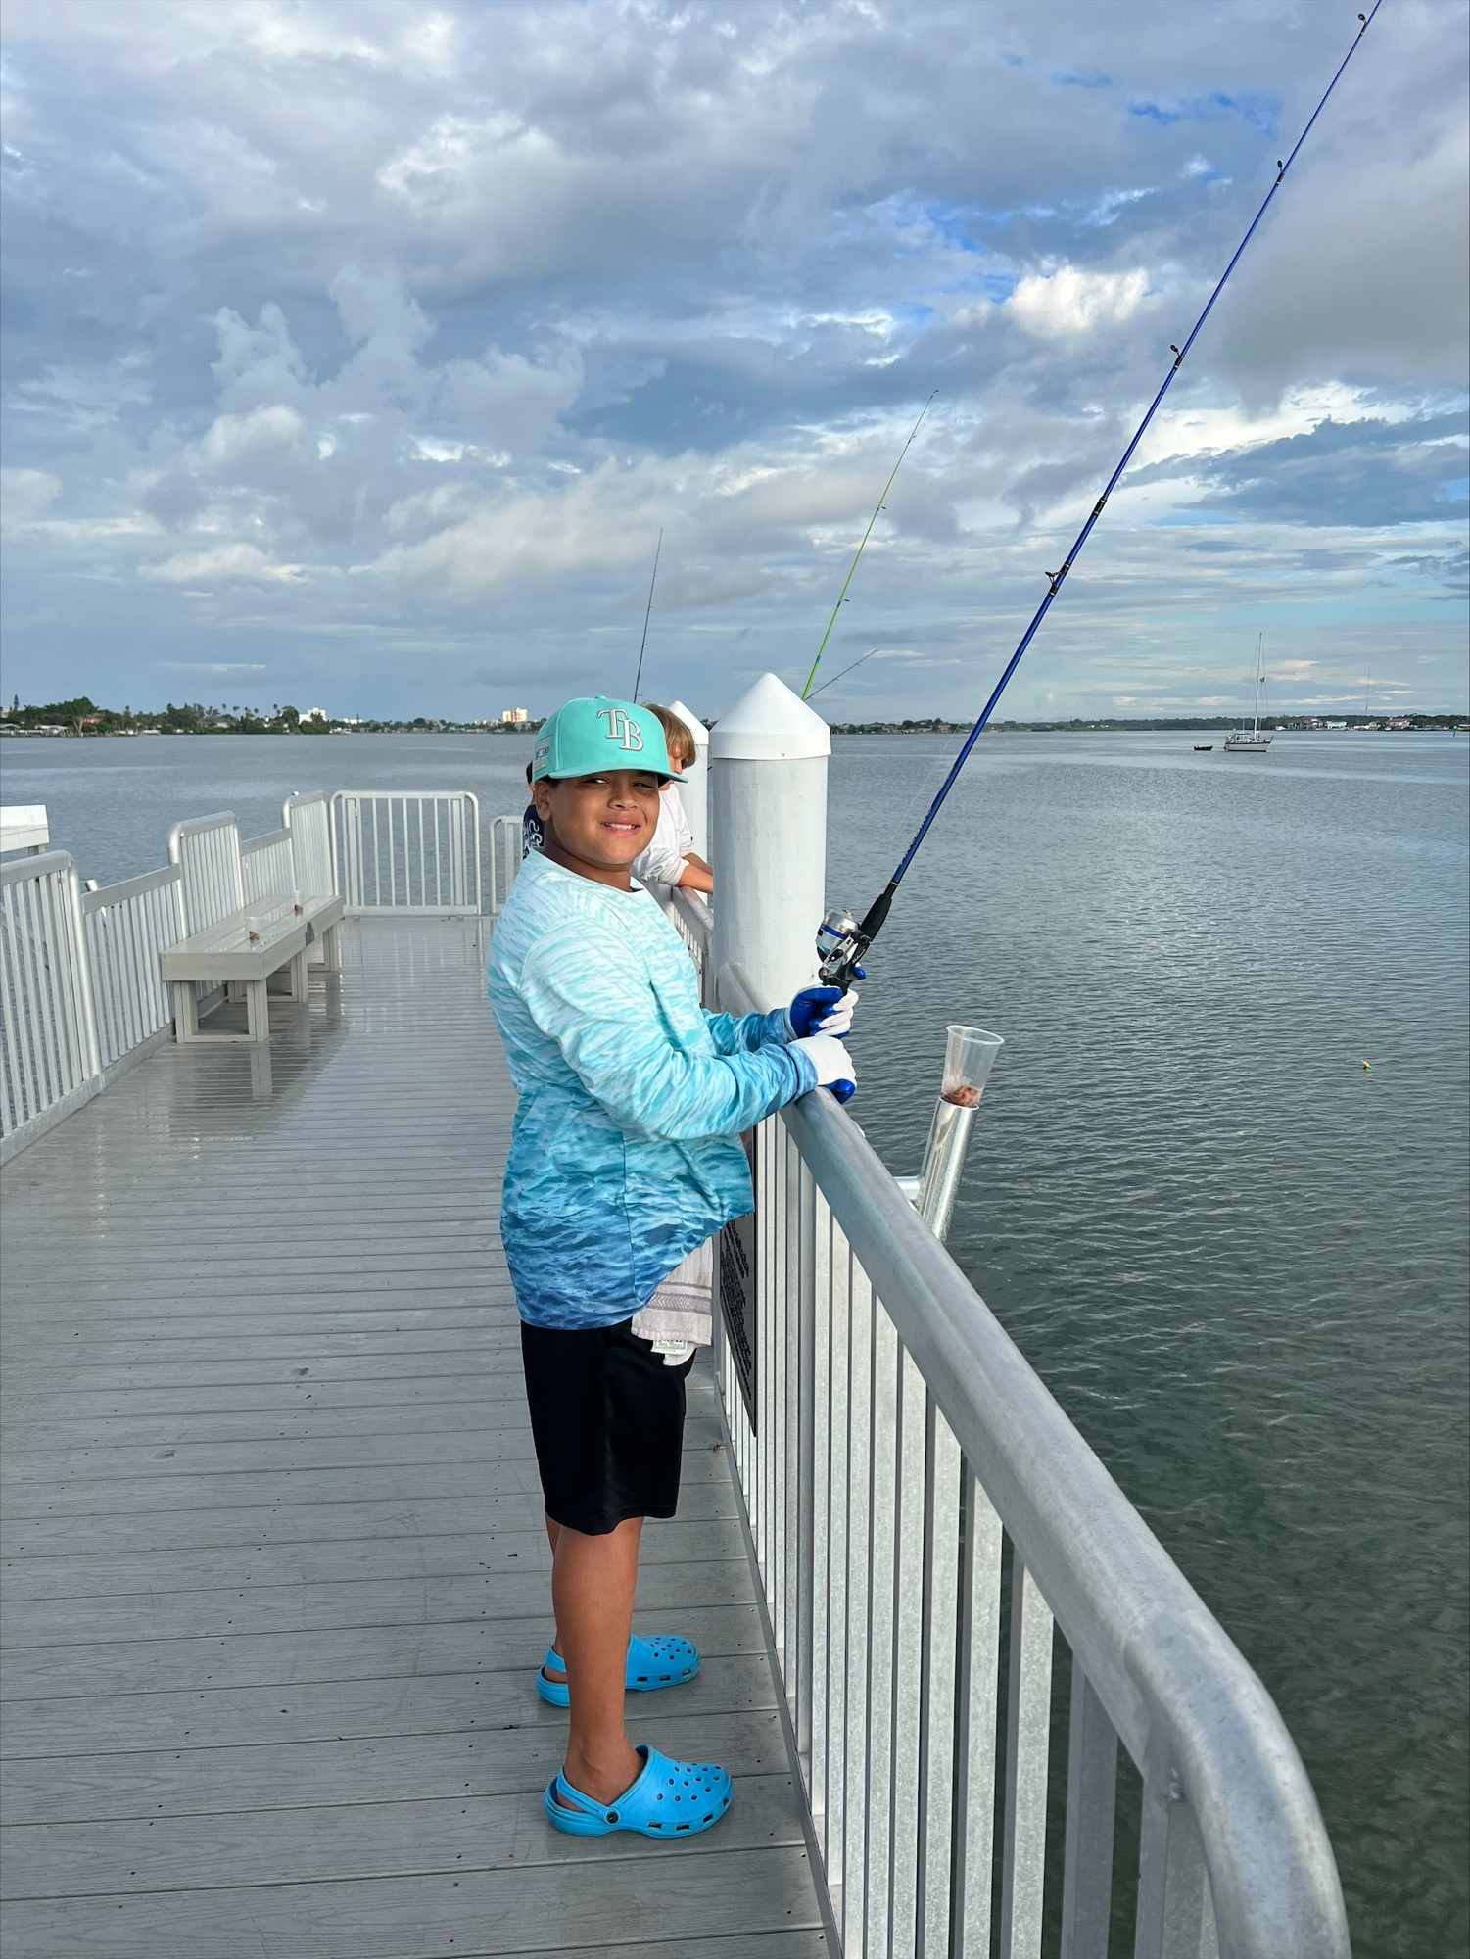

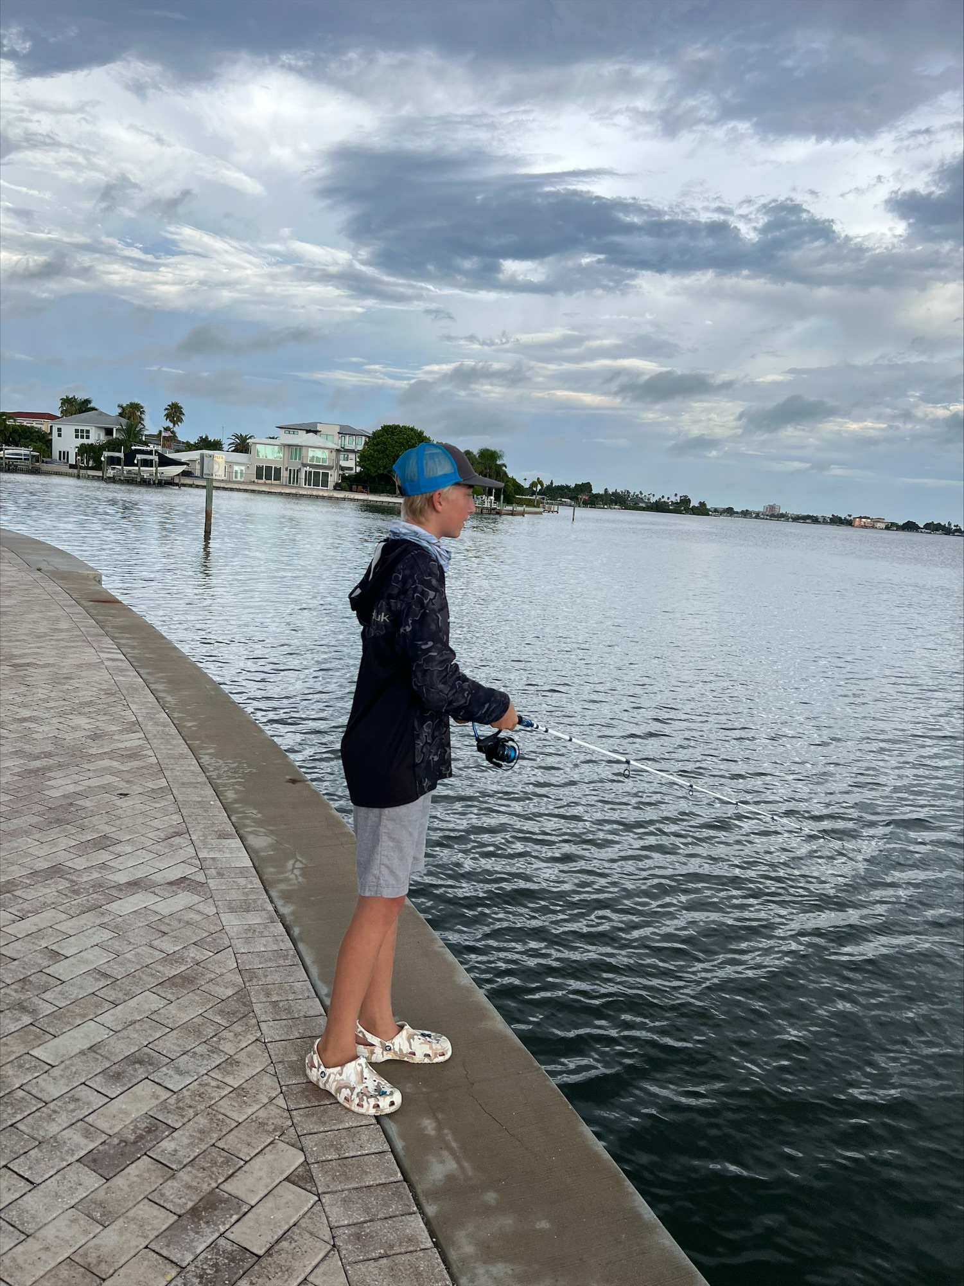

VIP BREAKFAST – SPONSORED BY
WALMART NEIGHBORHOOD STORE #04669
